St Gregory’s Catholic Primary School
‘Loving and Learning’
The St Gregory’s Curriculum
English
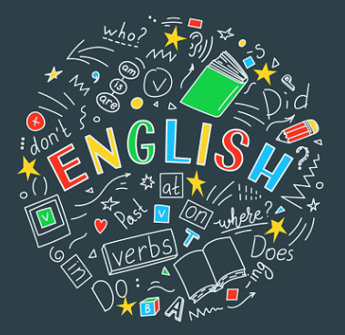
“We are a single family, dwelling in a common home.” Pope Francis, Fratelli Tutti, 17
‘Whatever you do, work at it with all your heart, as working for the Lord, not for human masters. Our writing is a form of worship to God and we should always write as if for Him instead of wondering what others will think.’ Colossians 3:23
Catholic Social Teaching
Participation.
Catholic School Pupil Profile
Eloquent. Truthful.
Curriculum Intent for English
To provide pupils with a love for reading which in turn promotes a love for writing. Our pupils will be given opportunities to implement these skills to access the wider curriculum. Our pupils are given regular opportunities to read and also listen to texts; to further their understanding and broaden their knowledge of different genres and text types. Our Writing Curriculum includes texts which are carefully selected to encourage pupils to learn about the world and the curriculum as a whole, linking to our thematic topics. As pupils progress through the year groups, they will build on their listening, speaking, reading and writing skills which will broaden their imagination, deepen their understanding and enjoy reading for pleasure.
Curriculum Implementation for English
Starting from EYFS, our pupils access the English curriculum whilst learning phonics and develop their early reading skills through the Read Write Inc scheme. EYFS and KS1 children progressively acquire and apply a growing knowledge of phonemes and graphemes to produce phonetically plausible writing. Pupils read fluently at their phonetic level whilst also reading and writing through our English Curriculum.
Pupils are provided with daily English lessons including Read Write Inc from EYFS, to writing lessons and weekly whole class reading in KS1, then additional weekly SPAG lessons in KS2. Our Writing Curriculum enables children to be provided with a wide range of texts which exposes pupils to different genres of writing, encouraging them to write creatively and imaginatively. Each term, pupils are given opportunities to explore fiction, non-fiction, thematic and poetry text types. Texts are selected to incorporate thematic opportunities and include writing for different purposes and audiences. Grammatical skills are progressively taught and built from EYFS through to KS2 so that the children are well-equipped to become successful authors.
To enable pupils to further their comprehension skills, children are given ‘Reading Superheroes’ which support pupils to question, infer, predict, summarise and retrieve information that they are given. Weekly whole class reading lessons given the children the opportunity to practise these skills and teachers use the long-term reading overviews to ensure that these skills are practised and embedded.
Curriculum Impact for English
Pupils will be able to read fluently and not only decode words on a page, but also naturally infer, question, predict, retrieve and summarise texts that they are reading. Pupils will complete ‘Reading Quests’ annually which include carefully selected texts based on the 5 plagues of reading. Pupils will be confident in using the school library, classroom book corners or local libraries to enter into wonderful imaginative worlds and realising that the world around them is full of new, exciting and endless possibilities.
Assessment will be ongoing and pupils will self-assess, edit and improve their own writing. Writing Assessment grids are used by teachers termly to assess the writing skills of the pupils at their age-related expectations. They will recognise how to use vocabulary to write for different intents, purposes and audiences. Pupils will use legible cursive handwriting in KS2 with increased speed and recognise how to select appropriate grammar and vocabulary whilst recognising how their choices can change and enhance the meaning of what they write.
Reading and spelling age assessments are used to track the progress of pupils whilst also assessing their comprehension termly. These assessments result in teachers intervening when appropriate to support any pupils who need to practise any particular reading or writing skills.
All pupils at St. Gregory’s will have access to high-quality texts and develop a wealth of knowledge of grammar, spelling patterns, authors and text-types to write successfully for different purposes. They will have a broad imagination and enjoy reading for pleasure.

